Lab – Configuring a Wireless Router and Client

1. Topology

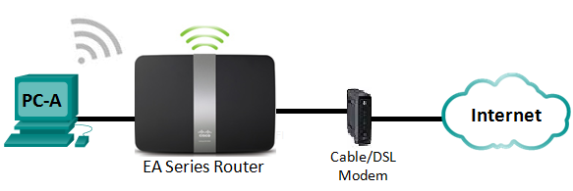

1. Linksys Router Settings

|  |  |
| --- | --- |
| Network Name (SSID) | CCNA-Net |
| Network Password | cisconet |
| Router Password | cisco123 |

1. Objectives

Part 1: Configure Basic Settings on a Linksys EA Series Router

Part 2: Secure the Wireless Network

Part 3: Review Additional Features on a Linksys EA Series Router

Part 4: Connect a Wireless Client

1. Background / Scenario

Surfing the web from anywhere in the home or office has become common. Without wireless connectivity, users would be limited to connect only where there is a wired connection. Users have embraced the flexibility that wireless routers provide for accessing the network and the Internet.

In this lab, you will configure a Linksys Smart Wi-Fi router, which includes applying WPA2 security settings and activating DHCP services. You will review some added features available on these routers, such as USB storage, parental controls, and time restrictions. You will also configure a wireless PC client.

1. Required Resources

* 1 Linksys EA Series Router (EA4500 with firmware version 2.1.39.145204 or comparable)
* 1 Cable or DSL modem (Optional - needed for Internet service and normally supplied by ISP)
* 1 PC with a Wireless NIC (Windows 7, Vista, or XP)
* Ethernet cables as shown in the topology

1. Configure Basic Settings on a Linksys EA Series Router

The most efficient way to configure basic settings on an EA Series router is to run the Linksys EA Series Setup CD that came with the router. If the Setup CD is unavailable, download the Setup program from <http://Linksys.com/support>.

* 1. Insert the Linksys EA-Series Setup CD into the PC.

When prompted, select **Set up your Linksys Router**. You will be asked to read and accept the License Terms for using the software. Click **Next >** after accepting the license terms.

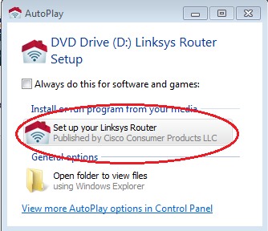

* 1. Cable the network as shown in the topology.

Follow the directions in the next window for connecting the power cable and Ethernet cable from your cable modem or DSL modem. You may connect the PC to one of the four unused Ethernet ports on the back of the router. After you have connected everything, click **Next >**.

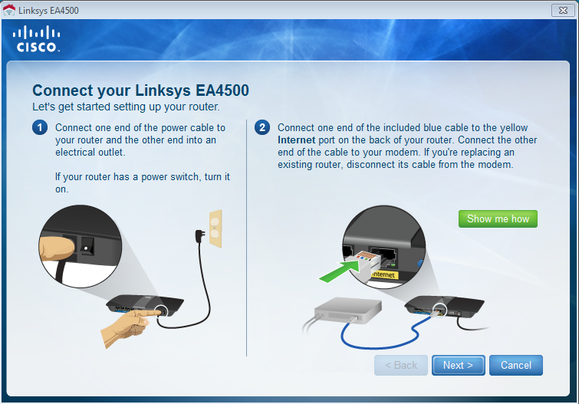

* 1. Configure Linksys router settings.
     1. Allow time for the **Linksys router settings** window to display. Use the **Linksys Router Settings** table at the beginning of this lab to fill in the fields in this window. Click **Next** to display the summary router settings screen. Click **Next**.

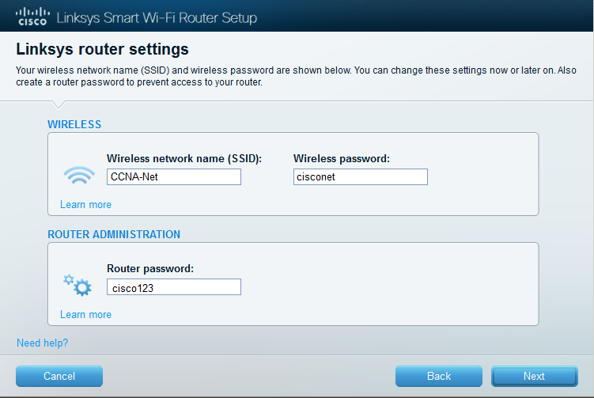

* + 1. The **Create your Linksys Smart Wi-Fi account** window displays. A Linksys Smart Wi-Fi account associates your router to the account, allowing you to remotely manage the router using a browser or mobile device running the Smart Wi-Fi app. For this lab, bypass the account setup process. Click the **No thanks** box and press **Continue**.

**Note**: An account can be setup by browsing to [www.linksyssmartwifi.com](http://www.linksyssmartwifi.com).

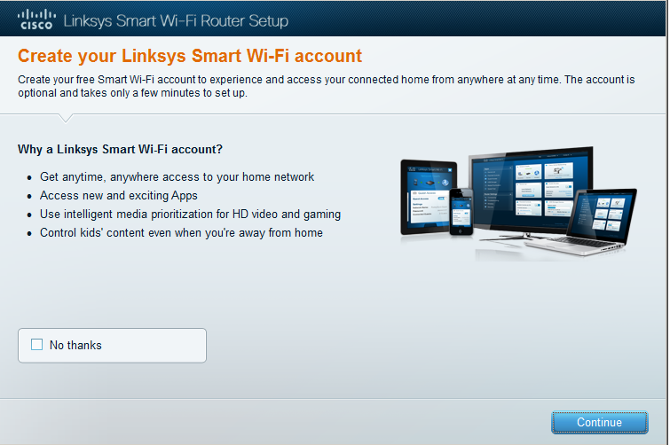

* + 1. A **Sign In** window displays. In the **Access Router** field, enter **cisco123,** and click **Sign In**.

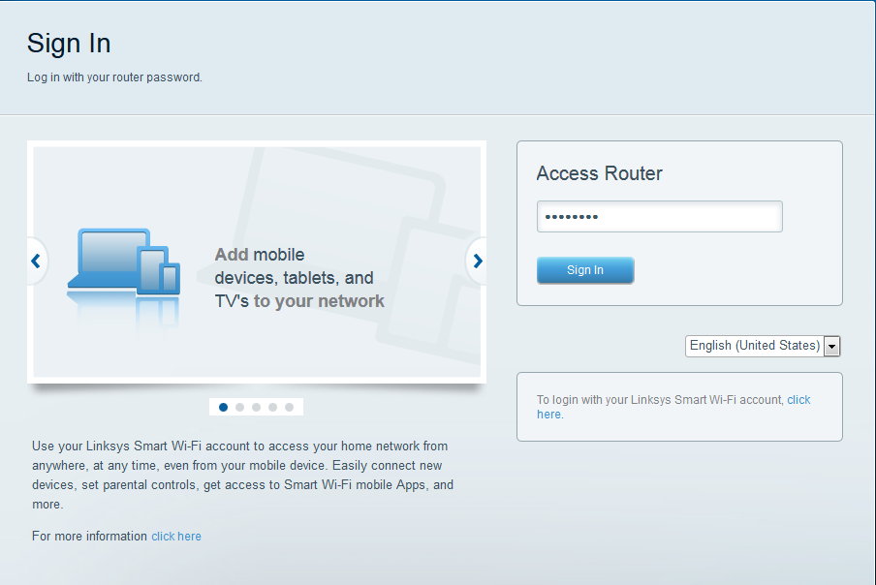

* + 1. On the Linksys Smart Wi-Fi home page, click **Connectivity** to view and change basic router settings.

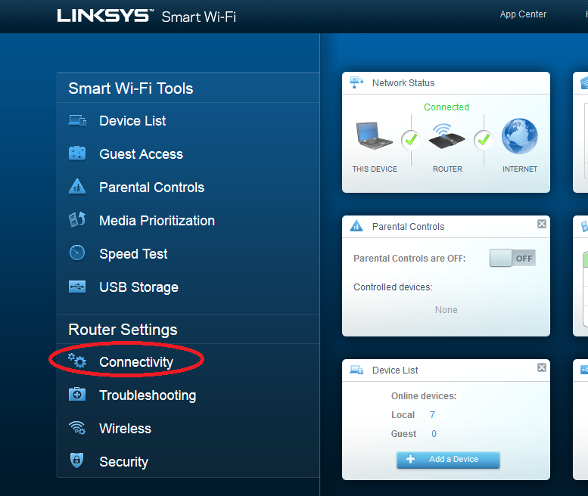

* + 1. On the **Basic** tab, you can edit the SSID name and password, change the router password, perform firmware updates, and set the time zone for your router. (The router password and SSID information was set in Step 3a.) Select the correct time zone for your router from the drop-down box and click **Apply**.

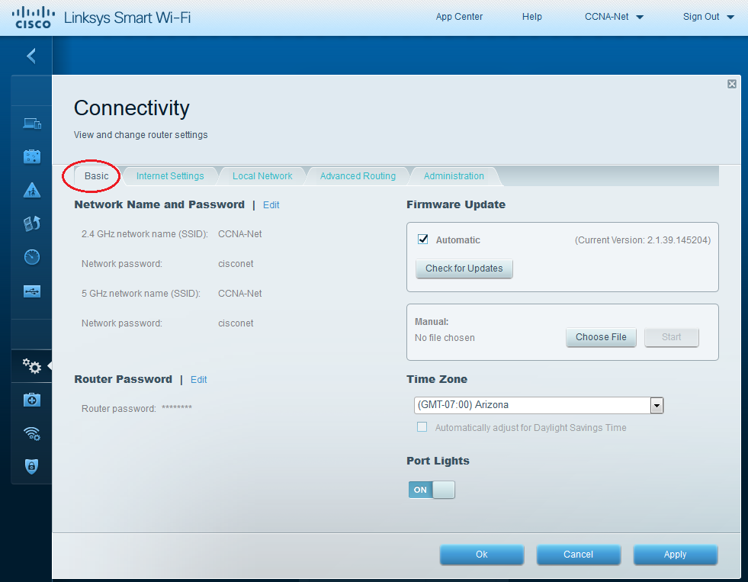

* + 1. The **Internet Settings** tab provides information about the Internet connection. In the example, the router automatically configured the connection for DHCP. Both IPv4 and IPv6 information can be displayed from this screen.

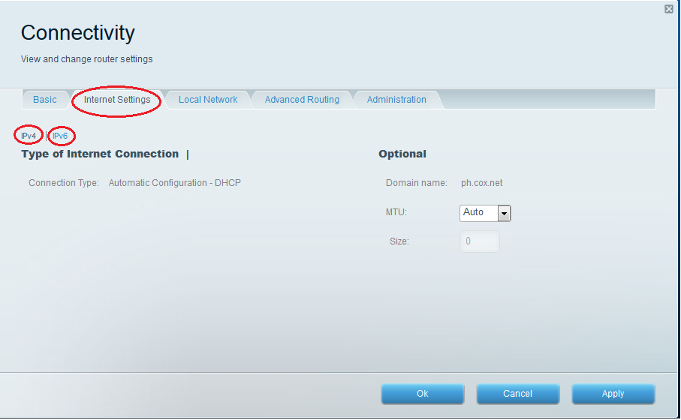

* + 1. The **Local Network** tab controls the local DHCP server settings. The default local network settings specify the 192.168.1.0/24 network and the local IP address of the default router is 192.168.1.1. This can be changed by clicking **Edit** next to **Router Details**. DHCP Server settings can be changed on this screen. You can set the DHCP starting address, maximum number of DHCP users, client lease time, and static DNS servers. Click **Apply** to accept all changes made on this screen.

**Note**: If DHCP is used to obtain ISP connection information, these DNS addresses will most likely be populated with the ISP’s DNS server information.

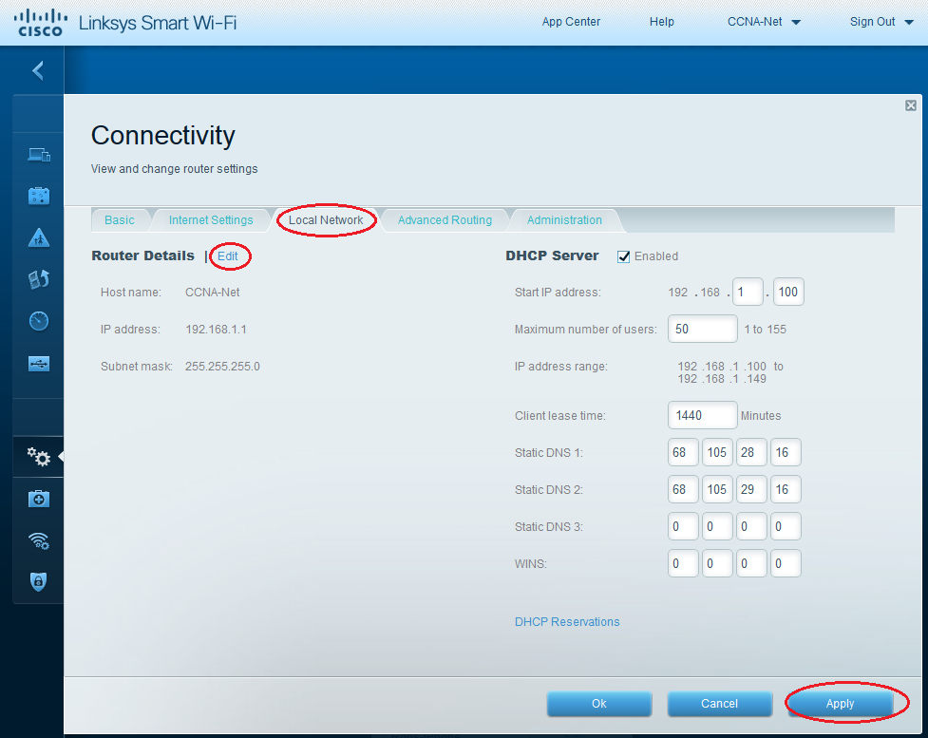

* + 1. The **Advanced Routing** tab allows you to disable Network Address translation (NAT), which is enabled by default. This screen also allows you to add static routes. Click **Apply** to accept any desired changes made on this screen.

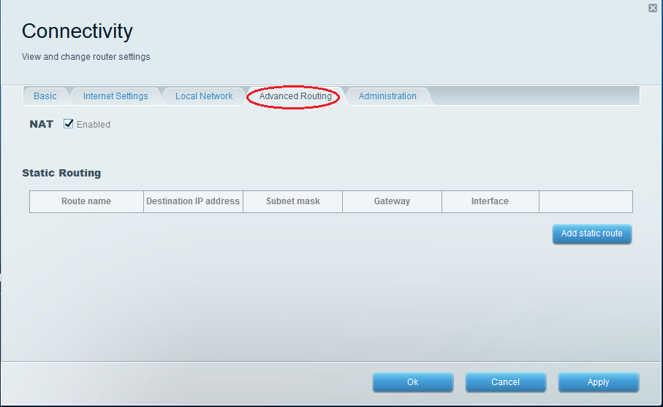

* + 1. The **Administration** tab provides controls for the management of the Smart Wi-Fi software. By chicking the appropriate box, you can activate remote management access to the router. You can also activate HTTPS access and restrict wireless management. Universal Plug and Play (UPnP) and Application Layer Gateway controls are also available on this screen. Click **Apply** to accept any desired changes made on this screen.

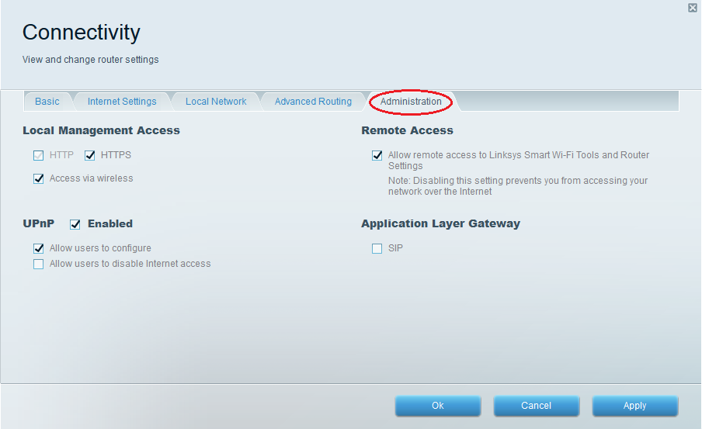

1. Secure the Wireless Network

In Part 2, you will secure the Linksys EA series router wireless network and review firewall and port forwarding options on a Linksys Smart Wi-Fi router.

* 1. Add WPA security on the wireless routers.
     1. From the Linksys Smart Wi-Fi home page, click **Wireless**.

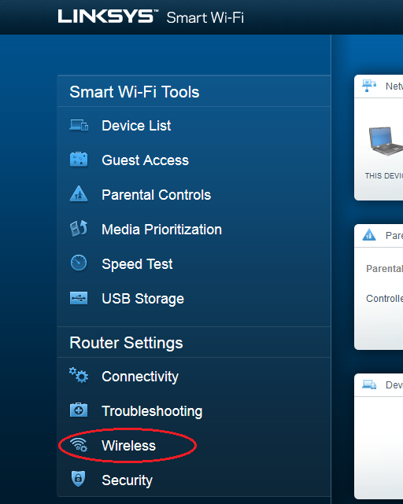

* + 1. The **Wireless** window displays the settings for both the 2.4 and 5 GHz radios. Use the **Edit** button next to each column to modify the security setting on each wireless frequency range. (The SSID and password were previously set in Part 1.) Click the **Security mode** drop-down list to select the **WPA2/WPA Mixed Personal** option for each range. Click **Apply** to save your settings, and then click **OK**.

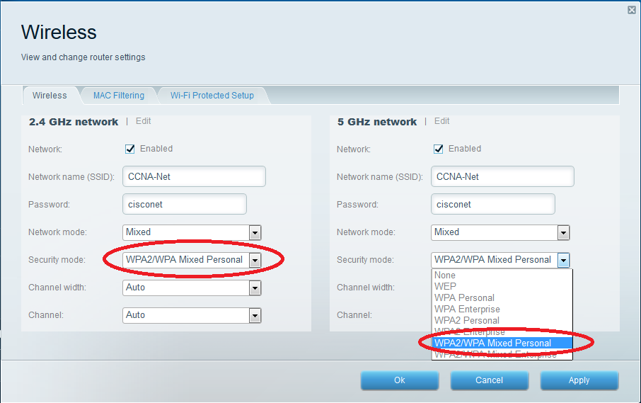

* 1. Apply firewall and port forwarding settings.
     1. From the Linksys Smart Wi-Fi home page, click **Security**. In the **Security** windows, the **Firewall**, **DMZ**, and **Apps and Gaming** tabs are available to view and change router security settings.

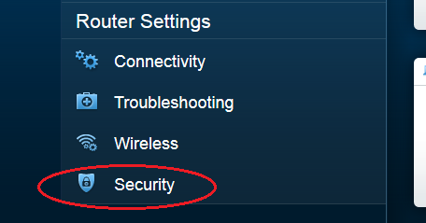

* + 1. The **Firewall** tab displays firewall settings, where you can enable or disable IPv4 and IPv6 Stateful Packet Inspection (SPI) firewall protection, Virtual Private Network (VPN) Passthrough options, and Internet filters. Click **Apply** to accept any desired changes made on this screen.

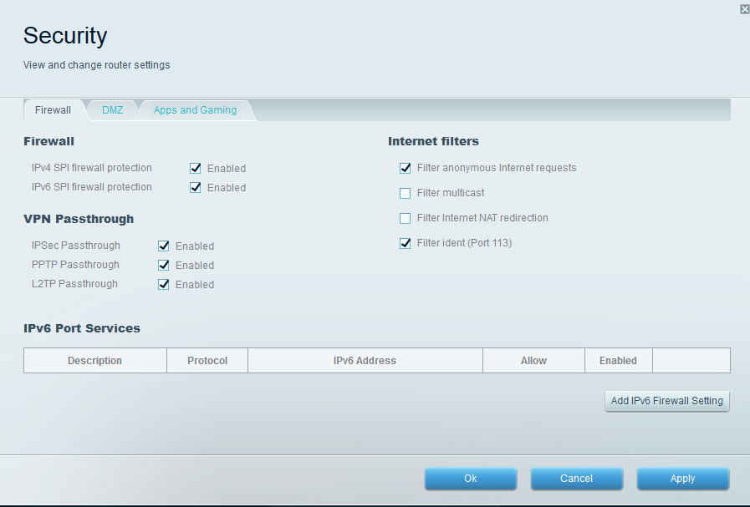

* + 1. The **Apps and Gaming** tab provides port forwarding capabilities. In the example, ports 5060 and 5061 have been opened for a VoIP Softphone application running on a local device at IP address 192.168.1.126. Click **Apply** to accept any desired changes made on this screen.

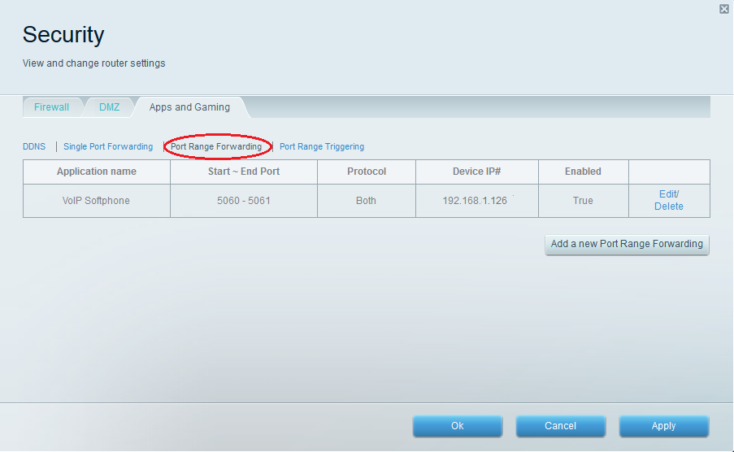

1. Review Additional Features on a Linksys EA Series Router

In Part 3, you will review some of the additional features available on the Linksys EA series router.

* 1. Review Smart Wi-Fi Tools.
     1. From the Linksys Smart Wi-Fi home page, click **Device List**.

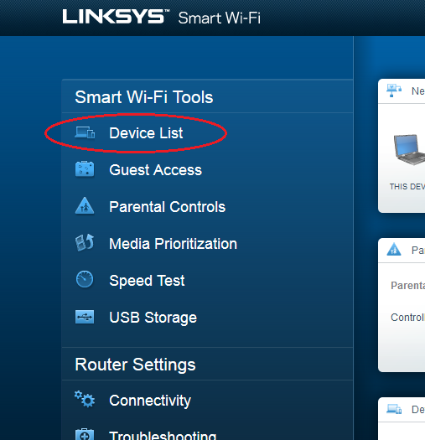

The **Device List** window displays the list of clients on the local network. Notice that there is a tab for the **Guest Network**. If the Guest network was activated, clients on that network would be displayed in the **Guest Network** tab.

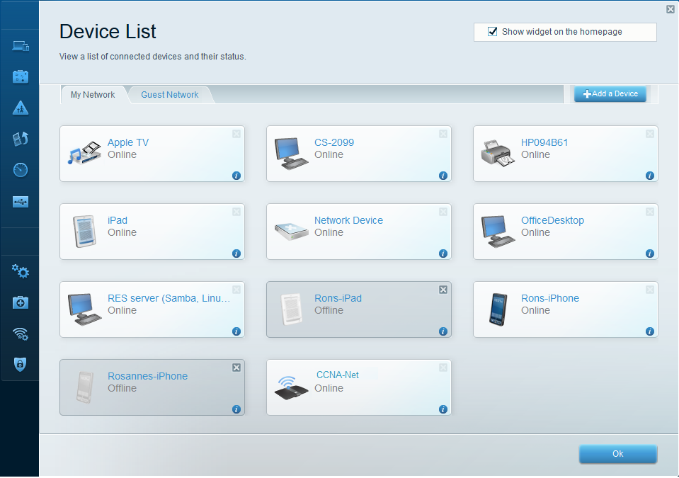

* + 1. From the Linksys Smart Wi-Fi home page, click **Guest Access**. Clients on the guest network only have access to the Internet and are unable to access other clients on the local network. To allow guest access, click on the **Allow guest access** toggle button. Click **Edit** link (next to the Guest network name and password) to change the Guest network password and click **OK** to accept the changes.

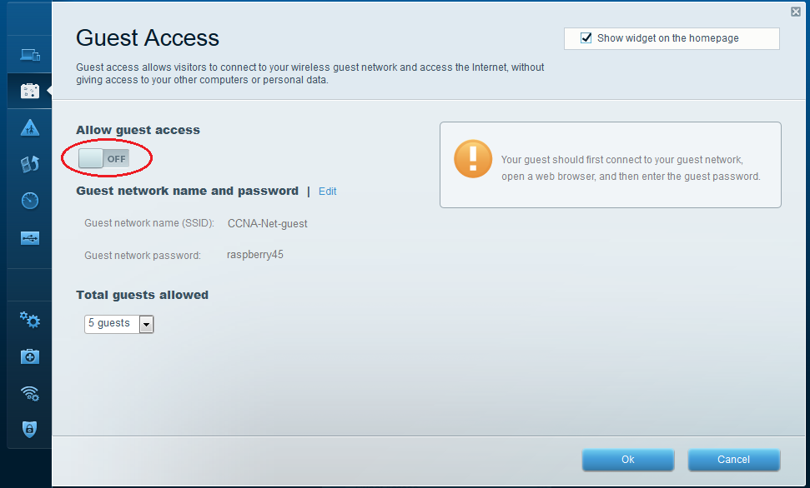

* + 1. From the Linksys Smart Wi-Fi home page, click **Parental Controls**. Use these settings to restrict Internet access on selected devices and to restrict time and websites. Click **OK** to save the settings.

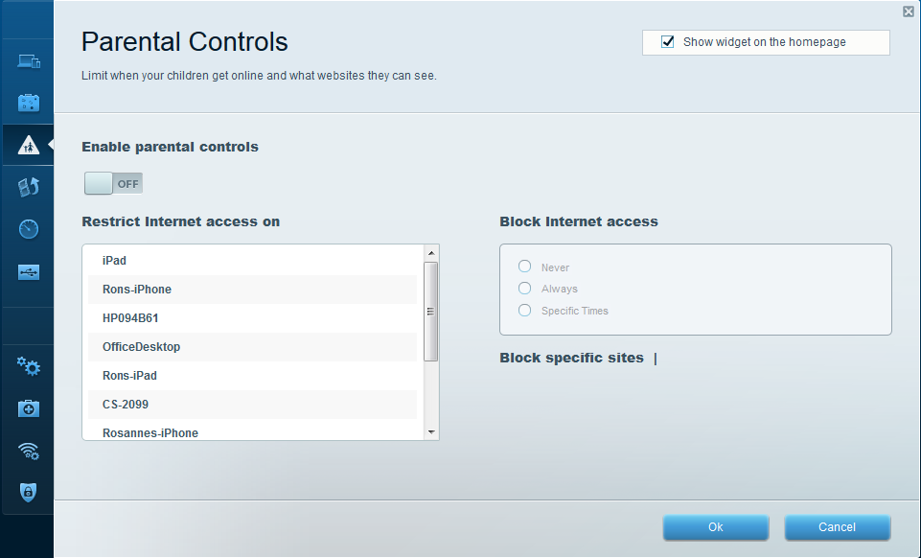

* + 1. From the Linksys Smart Wi-Fi home page, click on **Media Prioritization**. These settings allows you to assign network bandwidth prioritization to selected devices on the local network. In the example, the device labeled Apple TV has been given the highest priority for network resources. To make prioritization changes, just drag and drop the listed devices, and click **OK** to save your settings.

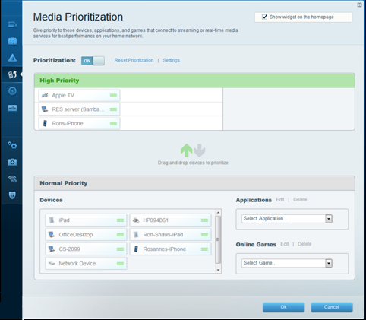

* + 1. From the Linksys Smart Wi-Fi home page, click **Speed Test**. Use this utility to test your Internet access speeds. The example shows the results of the speed test. The router stores the results of each speed tests and allows you to display that history.

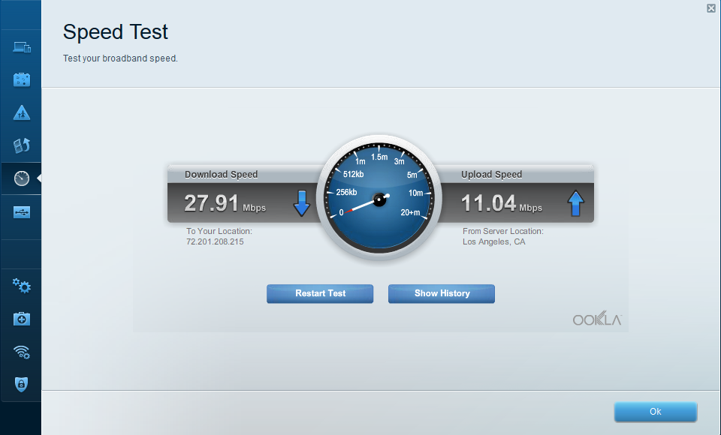

* + 1. From the Linksys Smart Wi-Fi home page, click **USB Storage**. Use this screen to review your USB drive settings. From here, you can click on the appropriate tab to set up FTP and Media Servers. You can also set up individual user accounts for access to these servers by clicking the tabs at the top of this screen. A USB storage device is plugged into the back of the router to use this option. Click **OK** to save any desired changes.

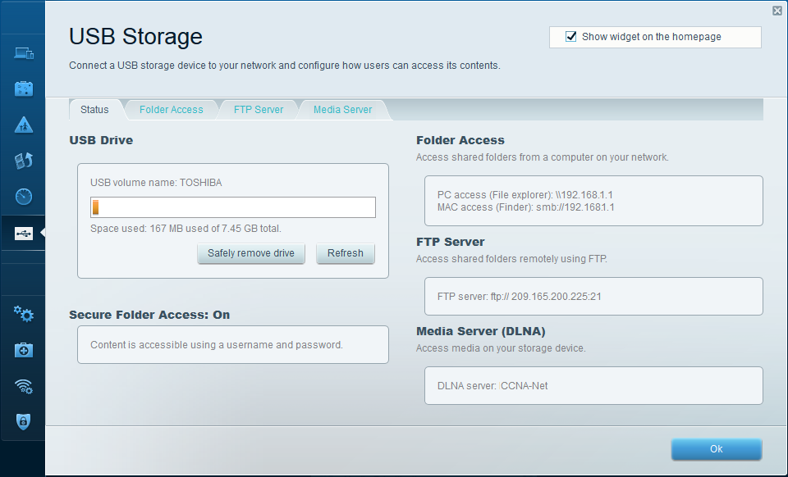

* 1. Troubleshoot the router.

From the Linksys Smart Wi-Fi home page, click **Troubleshooting**.

* + 1. The **Status** tab provides a list of clients on the local network along with their NIC MAC and IP addresses. It also displays how they are connected to the network. Click **OK** to save any desired changes.

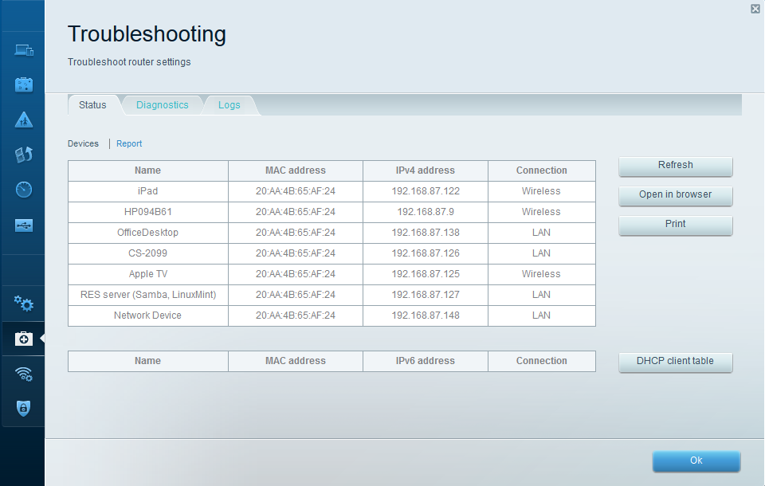

* + 1. The **Diagnostics** tab provides the ping and traceroute utilities. It also allows you to reboot the router, backup and restore the router configuration, restore a previous firmware version, release and renew the Internet addresses on your router, and reset to factory default settings. Click **OK** to save any desired changes.

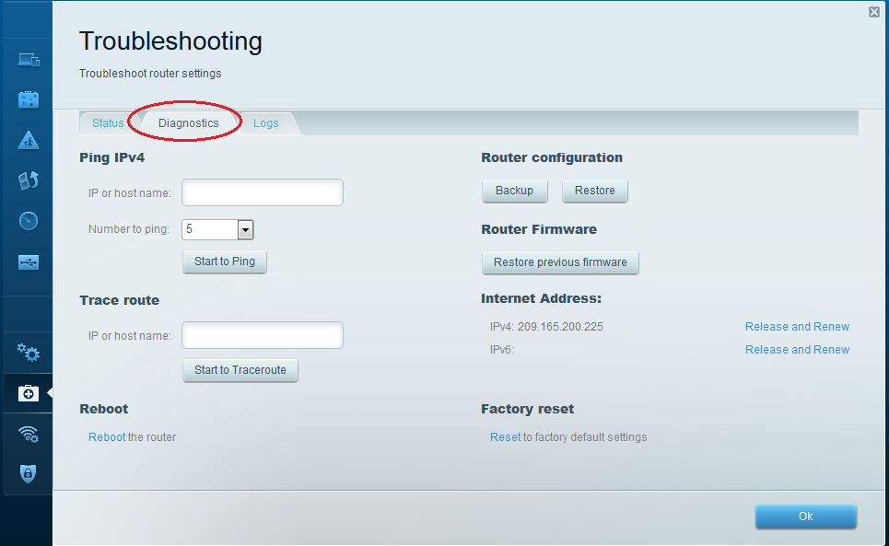

* + 1. The **Logs** tab provides Incoming and Outgoing, Security, and DHCP logs. You can print and clear these logs from this screen. Click **OK** to save any desired changes.

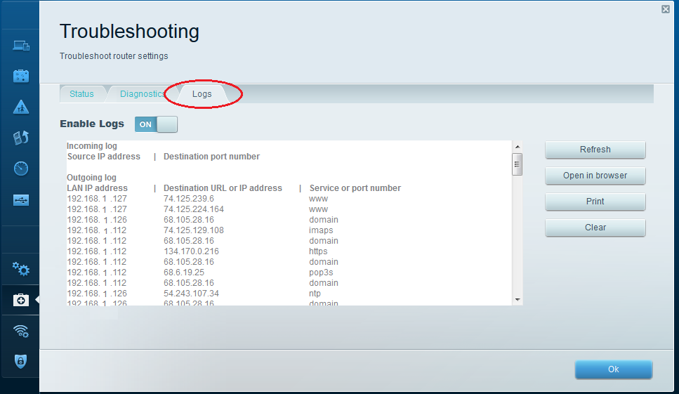

1. Connect a Wireless Client

In Part 4, you will configure the PC’s wireless NIC to connect to the Linksys EA Series Router.

**Note**: This lab was performed using a PC running the Windows 7 operating system. You should be able to perform the lab with other Windows operating systems listed; however, menu selections and screens may vary.

* 1. Use the Network and Sharing Center.
     1. Open the **Network and Sharing Center** by clicking the Windows **Start** button > **Control Panel** > **View network status and tasks** under Network and Internet heading in the Category View.
     2. In the left pane, click the **Change adapter settings** link.

The **Network Connections** window provides the list of NICs available on this PC. Look for your **Local Area Connection** and **Wireless Network Connection** adapters in this window.

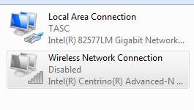

**Note**: VPN adapters and other types of network connections may also be displayed in this window.

* 1. Work with your wireless NIC.
     1. Select and right-click the **Wireless Network Connection** option to display a drop-down list. If your wireless NIC is disabled, you must **Enable** it.

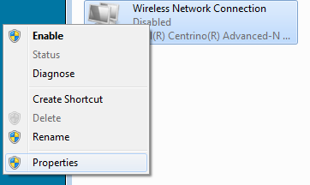

* + 1. Right-click the **Wireless Network Connection**, and then click **Connect/Disconnect**. This displays a list of SSIDs in range of your wireless NIC. Select **CCNA-Net**, then click the **Connect**.

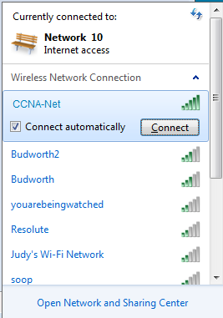

* + 1. When prompted, enter **cisconet** to supply the network security key, and then click **OK**.

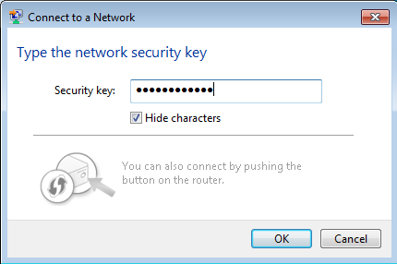

* + 1. The wireless icon should display in your taskbar when you have a wireless connection. Click this icon to display the list of SSIDs in range of your PC.



* + 1. The SSID **CCNA-Ne**t should now show that you are connected to the CCNA-Net wireless network.

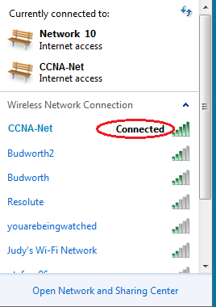

1. Reflection

Why would you not want to use WEP security for your wireless network?

_______________________________________________________________________________________

_______________________________________________________________________________________